1. Title
Beauty Shop – Online Beauty Product Shopping System
The project is a web-based beauty shopping application developed using HTML, CSS, JavaScript, PHP and MySQL. It provides product browsing, shopping cart, checkout, order placement and administrator order viewing functionalities.

2. Abstract
Beauty Shop is a simple online shopping system designed for browsing and purchasing beauty products through a web interface. The system displays products such as face cream, nail polish, hair serum and eye liner along with their descriptions, categories, prices and discounts. Users can add products to a shopping cart, modify quantities, proceed to checkout, enter customer and delivery details, select a payment method and place an order. The order information is stored in a MySQL database. An administrator can view customer orders and the products included in each order. The project demonstrates the integration of frontend web technologies with PHP and MySQL for an Internet Programming Lab application.

Database Connection – db.php
<?php
$conn = new mysqli("localhost", "root", "", "beauty_shop");
if ($conn->connect_error) {
die("Database connection failed: " . $conn->connect_error);
}
?>

Product Retrieval – shop2.php
<?php
include "db.php";
$result = $conn->query("SELECT * FROM products");
?>

Add to Cart – script.js
function addToCart(id, name, price) {
let cart = JSON.parse(localStorage.getItem("cart")) || [];
let existingProduct = cart.find(product => product.id == id);
if (existingProduct) {
existingProduct.quantity++;
} else {
cart.push({
id: id,
name: name,
price: Number(price),
quantity: 1
});
}
localStorage.setItem("cart", JSON.stringify(cart));
}

Order Insertion – place_order.php
$stmt = $conn->prepare(
"INSERT INTO orders
(user_id, total, customer_name, email, phone, address, city, pincode, payment_method)
VALUES (NULL, ?, ?, ?, ?, ?, ?, ?, ?)"
);

8. Screenshots
Insert screenshots captured from the running application in the spaces below. The screenshots should show the actual project execution in the browser and database.

Figure 1 – Home Page

Figure 2 – Shop Items / Product Listing

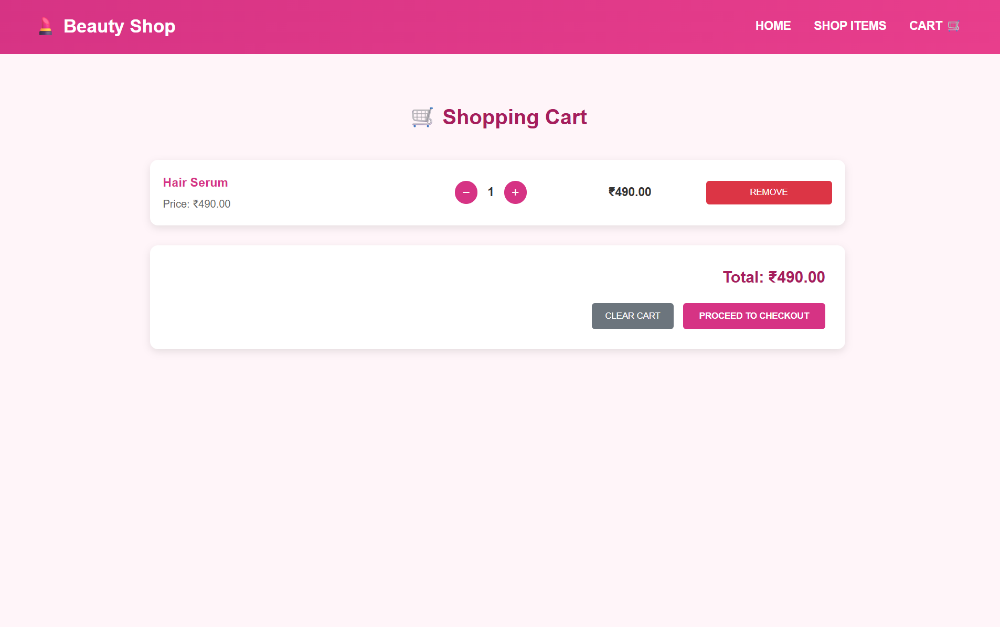
Figure 3 – Shopping Cart

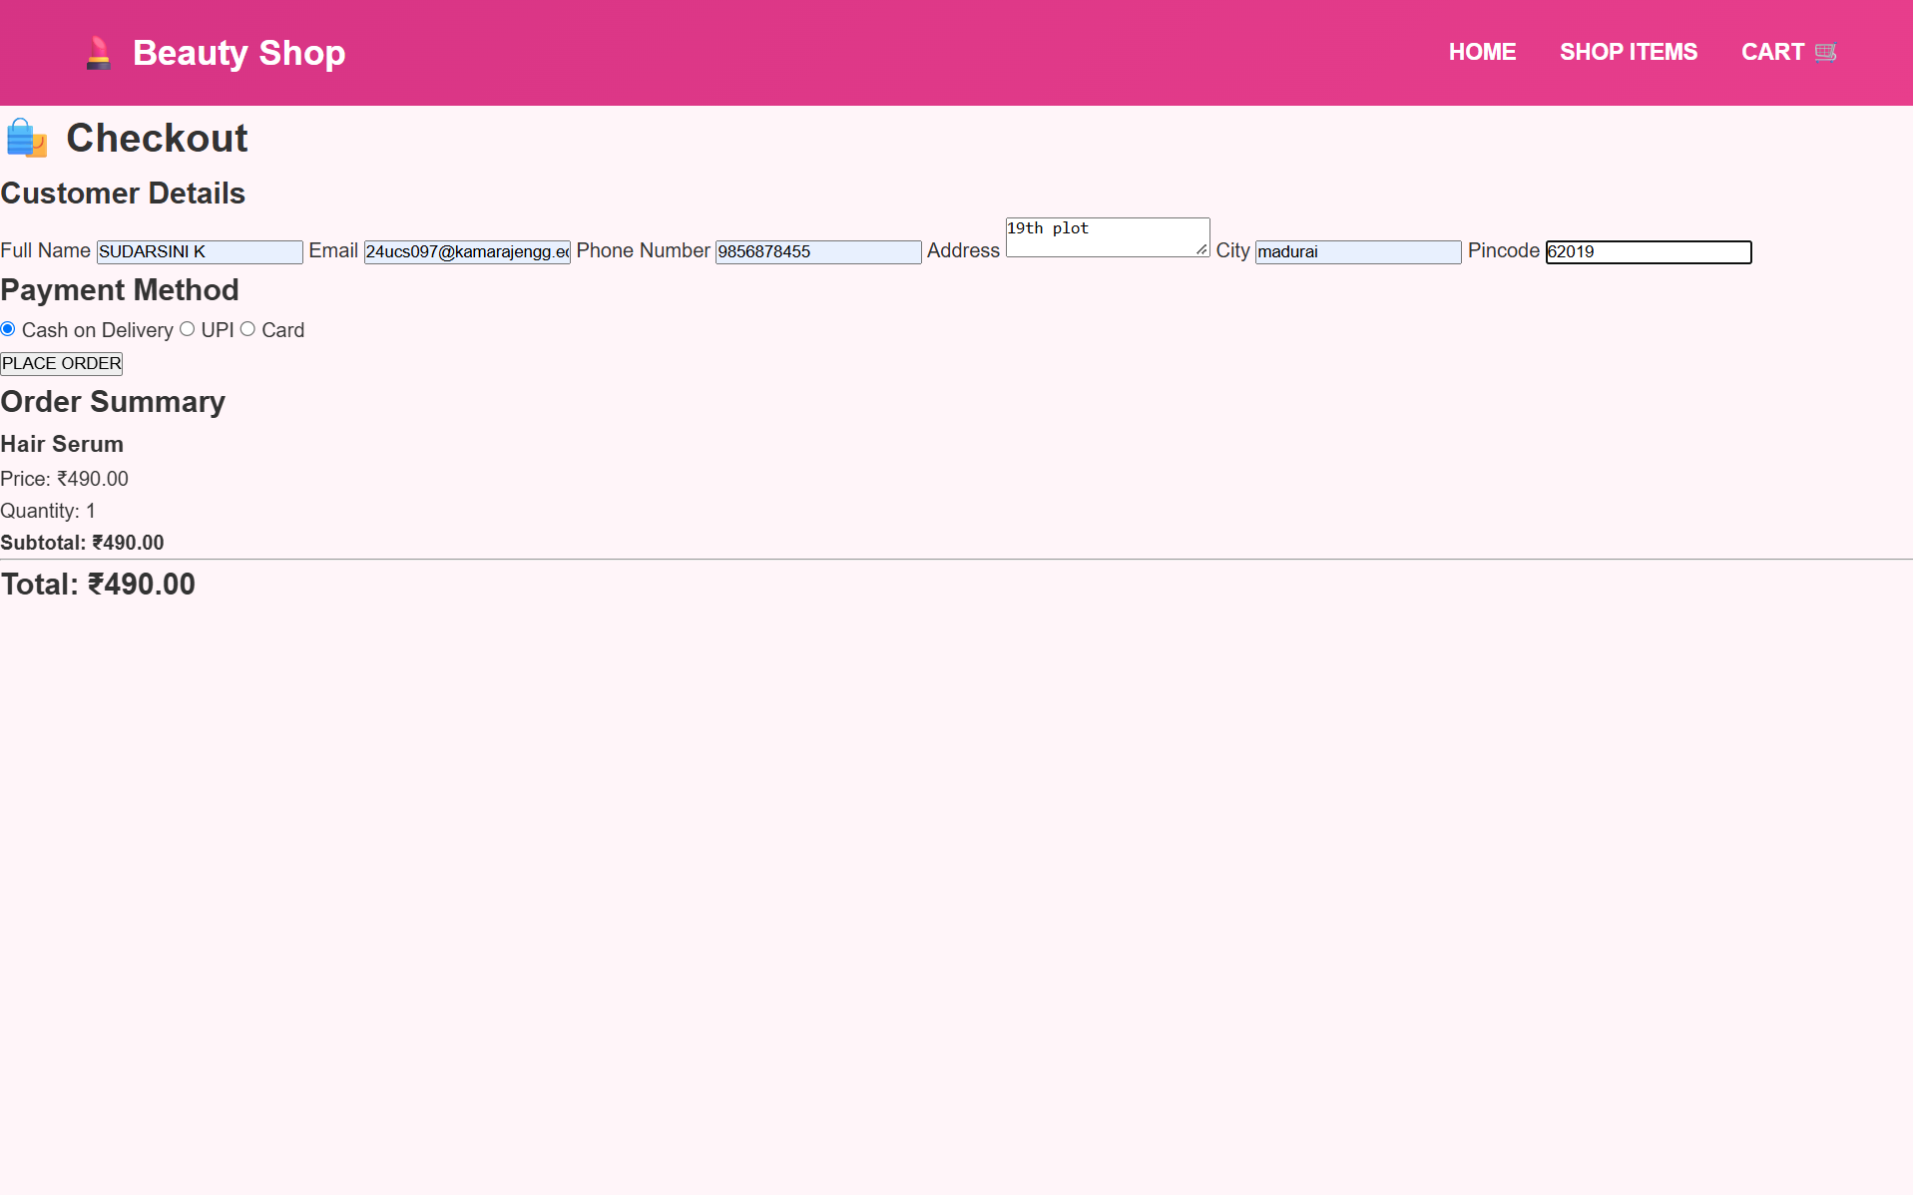
Figure 4 – Checkout Page

Figure 5 – Order Successfully Placed

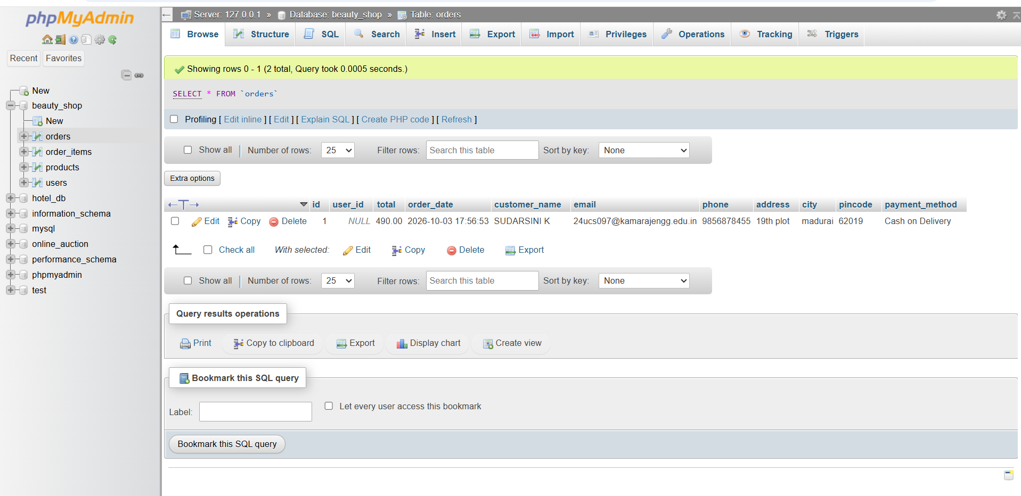
Figure 6 – Orders Table in phpMyAdmin
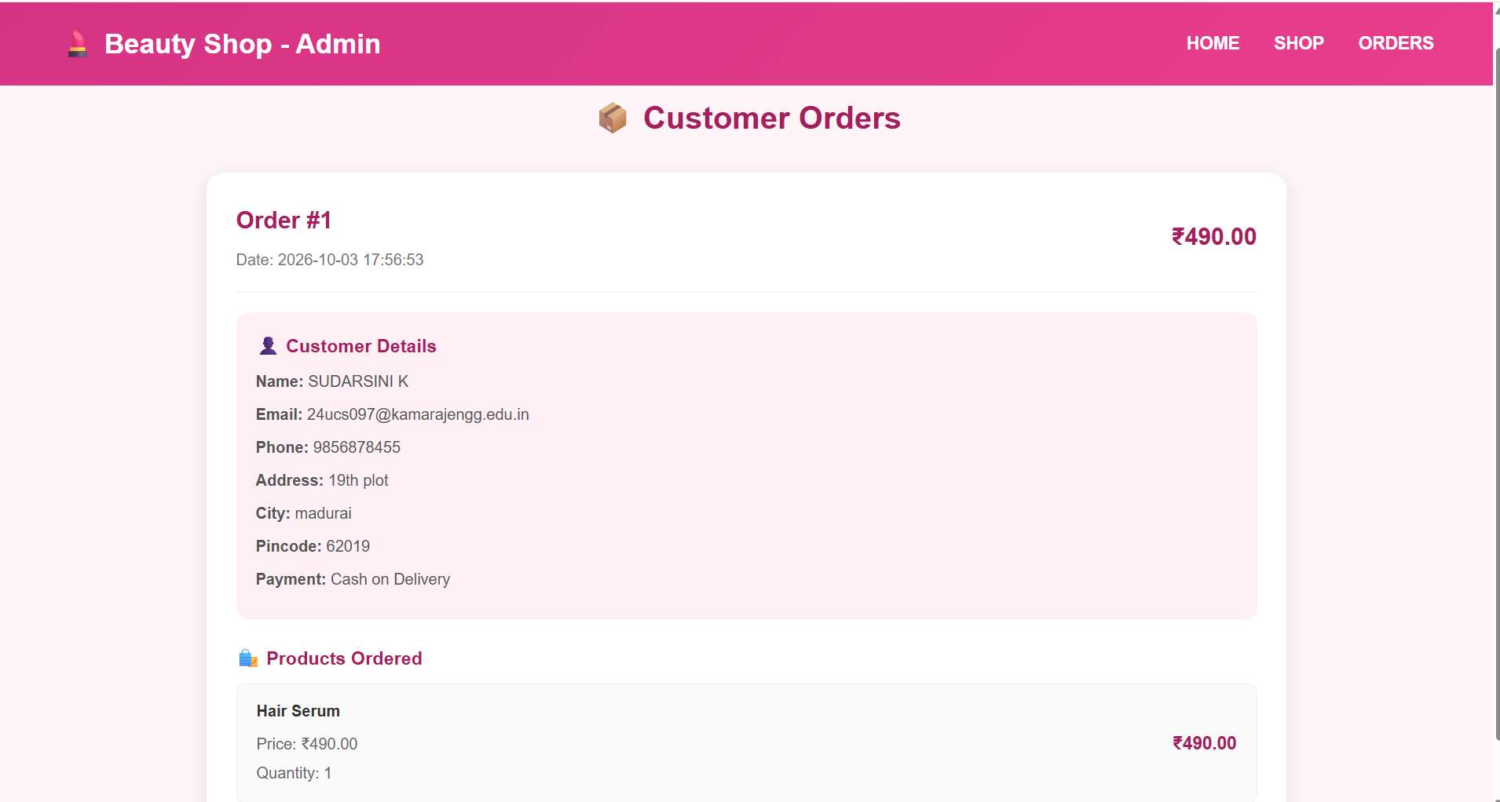
Figure 7 – Admin Orders Page

